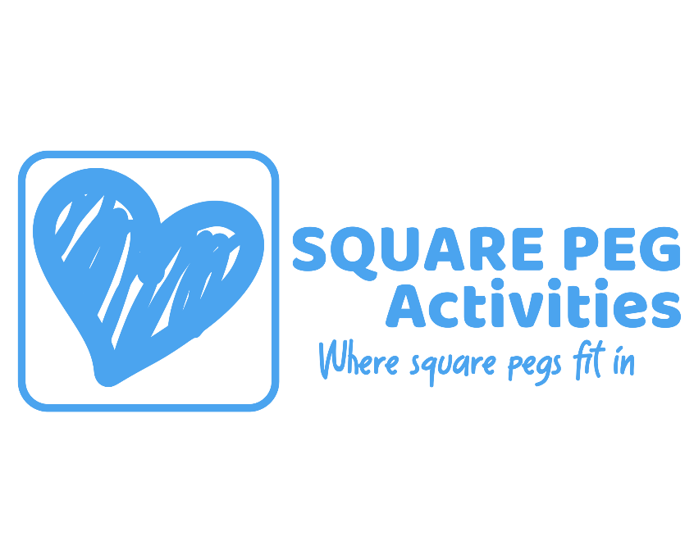

SAFEGUARDING CHILDREN
POLICY

Contents
- Introduction
- The four main Definitions of Abuse
- Reporting Concerns
- Receiving Concerns
- What to do when a child makes a disclosure
- Allegations against staff
- Useful contact details

1. Introduction
The organisation’s Directors are responsible for co-ordinating Safeguarding and promoting the welfare of children and young people and in particular protecting them from abuse and harm is a shared responsibility and depends on effective joint working between all staff, with all relevant agencies and professionals.

Our safeguarding policy and procedures and practices are aligned to both national and local guidance.

All of Square Peg Activities Limited services are required to follow the safeguarding procedures of Birmingham Safeguarding Children Partnership. www.lscpbirmingham.org.uk

All staff and volunteers have a responsibility to report any safeguarding concerns they have, that a child has or may be mistreated or harmed; and to take all allegations seriously; and report them to a DSL I the first instance.
The procedures in this Chapter are mandatory and any failure to comply with them will be addressed through appropriate procedures.
Staff must follow the local procedures for the area in which they are operating in, in many areas the information is available online.

2. The four main Definitions of Abuse

A person may abuse or neglect a child by inflicting harm, or by failing to act to prevent harm. Children and young people may be abused in a family or in an institutional or community setting; by those known to them or, more rarely, by a stranger. All forms of abuse such as Domestic Abuse, FGM, Child Exploitation etc. fall into the following categories.

- Physical Abuse may involve hitting, shaking, throwing, poisoning, burning, or scalding, drowning, suffocating, or otherwise causing physical harm to a child. Physical harm may also be caused when a parent or carer fabricates the symptoms of, or deliberately induces, illness in a child.
- Emotional Abuse involves the persistent emotional maltreatment of a child such as to cause severe and persistent adverse effects on the child’s emotional development. It may involve conveying to children that they are worthless or unloved, inadequate, or valued only insofar as they meet the needs of another person. It may include not giving the child opportunities to express their views, deliberately silencing them or "making fun" of what they say or how they communicate. It may feature age or developmentally inappropriate expectations being imposed on children. These may include interactions that are beyond the child’s developmental capability, as well as overprotection and limitation of exploration and learning, or preventing the child participating in normal social interaction. It may involve seeing or hearing the ill-treatment of another. It may involve serious bullying (including cyber-bullying) causing children frequently to feel frightened or in danger, or the exploitation or corruption of children. Some level of emotional abuse is involved in all types of maltreatment of a child, though it may occur alone.

- Neglect involves the persistent failure to meet a child's basic physical and/or psychological needs, likely to result in the serious impairment of the child's health or development. Neglect may occur during pregnancy as a result of maternal substance abuse. Once a child is born, neglect may involve a parent or carer failing to provide adequate food and clothing, shelter including exclusion from home or abandonment, failing to protect a child from physical and emotional harm or danger, failure to ensure adequate supervision including the use of inadequate caretakers, or the failure to ensure access to appropriate medical care or treatment. It may also include neglect of, or unresponsiveness to, a child's basic emotional needs.
- Sexual Abuse involves forcing or enticing a child or young person to take part in sexual activities, not necessarily involving a high level of violence, whether or not the child is aware of what is happening. The activities may involve physical contact, including assault by penetration (for example rape or oral sex) or non-penetrative acts such as masturbation, kissing, rubbing and touching outside of clothing. They may also include non-contact activities, such as involving children in looking at, or in the production of, sexual images, watching sexual activities, encouraging children to behave in sexually inappropriate ways, or grooming a child in preparation for abuse (including via the Internet). Sexual abuse is not solely perpetrated by adult males. Women can also commit acts of sexual abuse, as can other children.

3. Reporting Concerns

BSCP have a Right Help Right Time toolkit which should be used in assessing layers of need for a child/family.
In many instances an early help assessment may be needed in order to support a family from the need for a referral to children’s services. This can be undertaken with a family’s consent by a Health Visitor, School or other professional taking the lead.

When Abuse is Suspected
- In cases whereby abuse is suspected including concerns raised during therapeutic intervention or counselling sessions, staff and volunteers must raise the concerns with the DSL/Director, using the relevant concern form.
- Do not attempt to undertake your own investigation!
- Remind the child that you will need to share the information to gain support for them.
- Remain calm and reassuring.
- Make notes of what has been said or seen as soon as possible after speaking to the child.
- In the Director’s absence calls can be made to Children’s Advice and Support Service (CASS) 0121 303 1888 CASS@birminghamchildrenstrust.co.uk
- The same steps need to be made if there are concerns regarding child-on-child sexual abuse.
- If a child has been harmed or is at immediate risk of harm the police should also be contacted via 999 service.
- If the concern is of an historical nature this should still be passed on to CASS.
- Once notes have been made on the relevant form this must be signed (and name printed and dated by the individual completing)

4. Receiving Concerns

After receiving a report of a concern, suspicion or allegation of abuse or harm, the Director must firstly take any steps needed to protect any child or young person from risk of immediate harm.

The Director should ensure the following people are notified:
- CASS Children’s Social Care in the area where the organisation is based
- Any advice given by CASS will then be carried out by the Director/DSL

5. What to do when a child makes a disclosure
Receive: Listen to what is being said without displaying disbelief. If you display denial at what they are saying, the child may be afraid to continue. Accept what is being said without judgement. Take it seriously.

Reassure: Don’t make promises you can’t keep. Reassure the child that they did nothing wrong, and you take what is said seriously. Don’t promise confidentiality. You have a duty to report your concerns. Tell the child you will need to tell only those whose job it is to protect children.

React: Listen patiently. Don't investigate, interrogate, or decide if the child is telling the truth. An allegation of child abuse may lead to criminal investigation, don’t do anything that may jeopardise it. Let the child explain to you in their own words what happened, don’t ask leading questions. Ask open questions. Communicate with the child appropriately to their age or understanding. This is especially important for children with disabilities and children whose preferred language is not English. Don't ask the child to repeat what they have told you to another member of staff. Explain what happens next and whom you have to talk to. Refer directly to the named child protection officer or designated person in your organisation (as set out in the organisation’s child protection policy). Do not discuss the case with anyone outside the child protection team.

Record: Make brief notes at the time and write them up in detail as soon as possible. Do not destroy your original notes in case they are required by Court. Record the date, time, place, words used by the child and how the child appeared to you – be specific. Record the actual words used; including any swear words or slang. Record statements and observable things, not your interpretations or assumptions – keep it factual.

6. Allegations against Staff contact Birmingham LADO

LADO (Local Authority Designated Officer) Team, Birmingham City Council
Council House Extension
Margaret Street
Birmingham
B3 3BU
Tel: 0121 675 1669
Ladoteam@birmingham.gov.uk

- A person in a position of trust refers to any who:
- Has access to children or confidential information as part of their work.
What is an Allegation?
Information that indicates that a member of staff/volunteer may have:
- Behaved in a way that has harmed a child.
- Possibly committed a criminal offence against or related to a child.
- Behaved towards a child in such a way that indicates that he/she would pose a risk of harmed.
- If anyone within the organisation has any concerns that a staff member or volunteer has acted in any of the 3 categories above, they must not tell the perpetrator that an allegation has been made against them
- They must report it immediately to the Director/DSL who will immediately contact the LADO team at Ladoteam@birminghamchildrenstrust.co.uk

IT IS THE LADO TEAM’S RESPONSIBILITY TO BE:
- Involved in the oversight and management of:
- Processes for dealing with allegations against a person who works with children
- Provide advice guidance to case managers
- Chair LADO/Position of Trust meetings
- Liaise with other agencies and BSCP
Training

RHRT safeguarding training will be undertaken by every member of staff and volunteer team
https://www.lscpbirmingham.org.uk/training/elearning-course-rhrt?fbclid=IwAR04fXVJ4iRR7Tm8Tfly2hVQSBToHyTMHguoBCCDgxd5BJsNp_BrJ7smJ2w
(choose charity/other, the safeguarding lead is Rhona Davis

Other Relevant Policies

Mobile Phone Policy
Visiting Groups Policy
Safer Recruitment Policy
Whistle Blowing Procedures
E-Safety Procedures
NSPCC – lets talk pants can be found on the NSPCC website

7. Useful Contact Details

- Responsible Individual / Director: Sharon Needham 07947 354915 sharon@squarepegactivities.org
- Safeguarding Lead: Rhona Davis 07932 396367
- NSPCC 0808 800 5000

